USER GUIDE

ACA Certification

SecurePass

User initially logs in via SecurePass by entering in their username.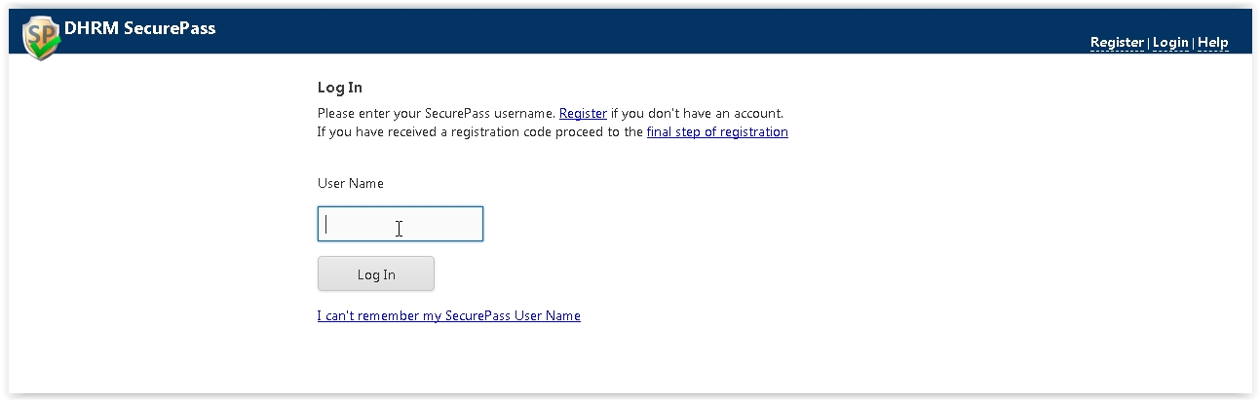

New accounts can be acquired via the Register link. This will generate a request that must be validated by an administrator. Upon approval, the registrant will be notified via email.

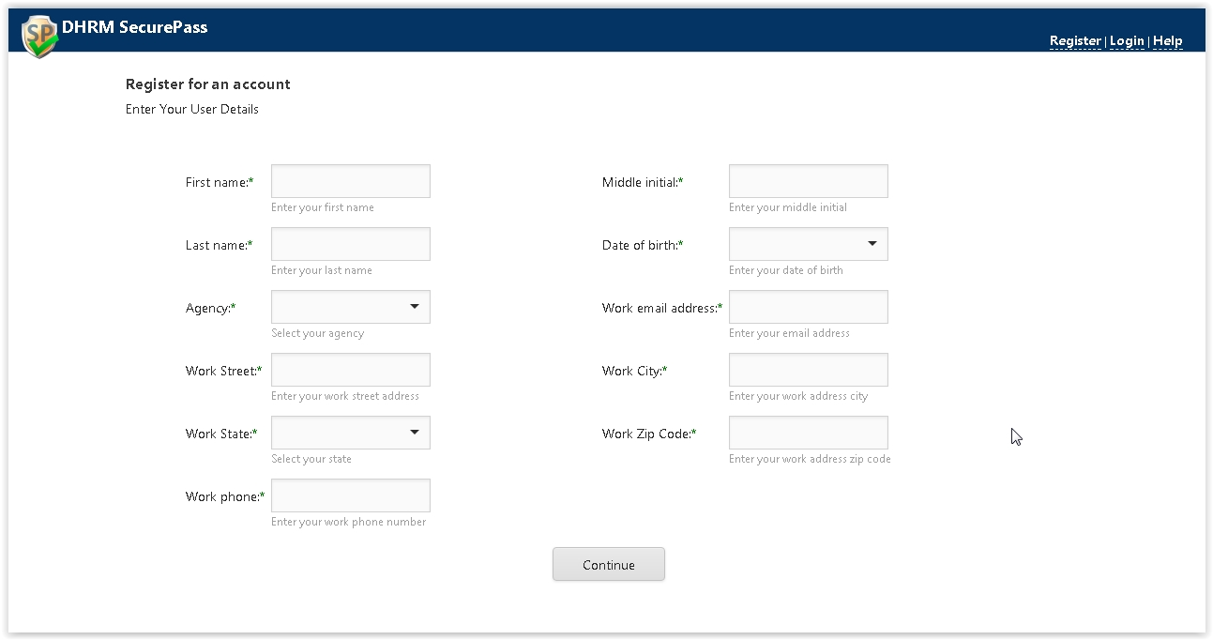

**Mock Security Portal**

This application mimics a logged in user. Used solely by developers to simulate the user environment. 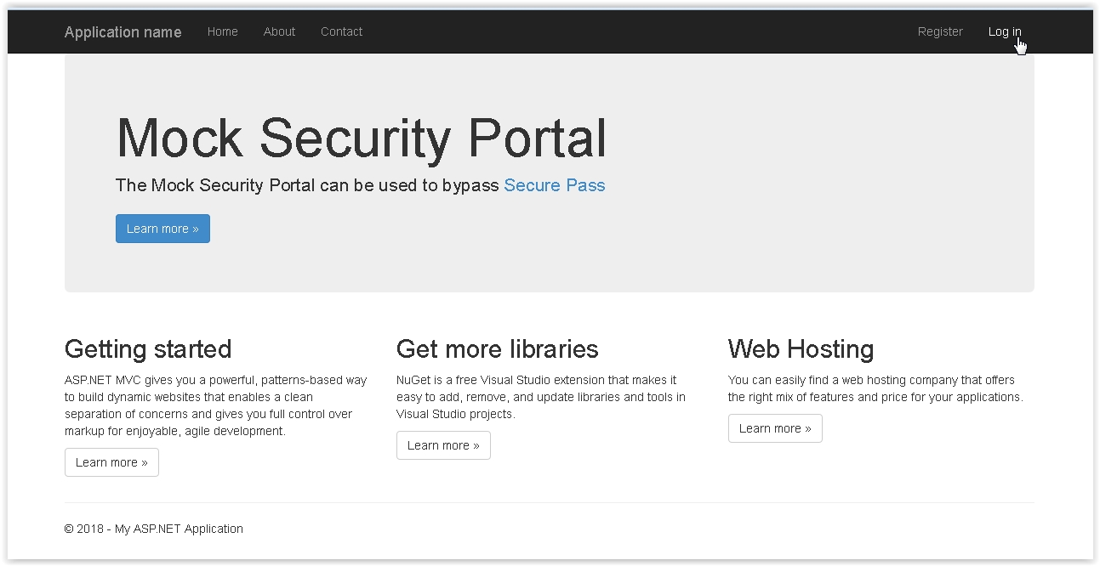

**User Name**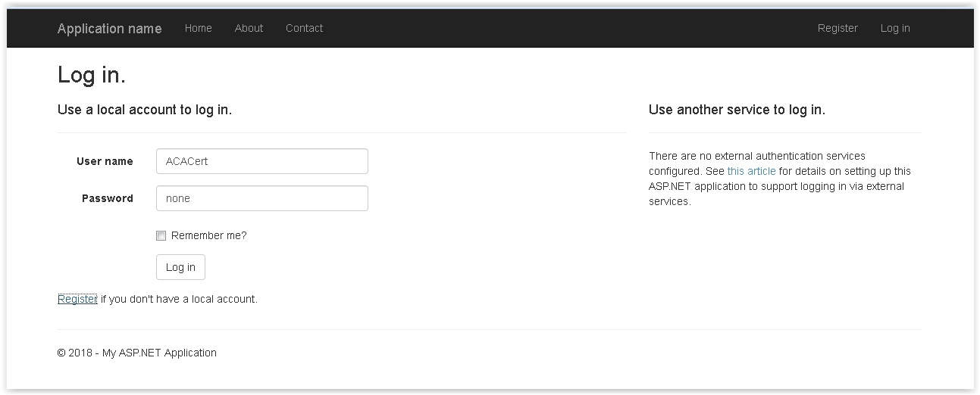

A user can determine which application to launch from the Log In screen.

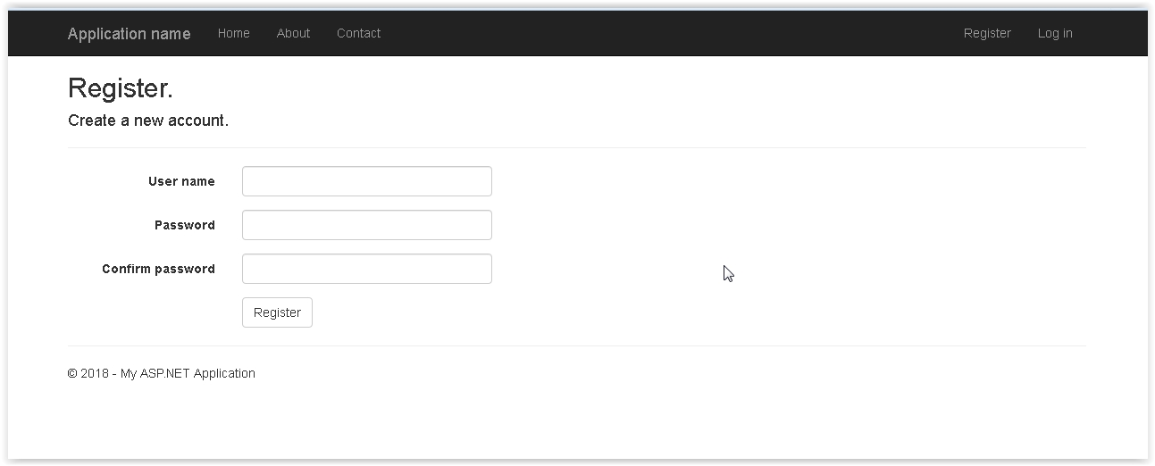

A new user can also Register for access privileges granted by an administrator.

**ACA Certification**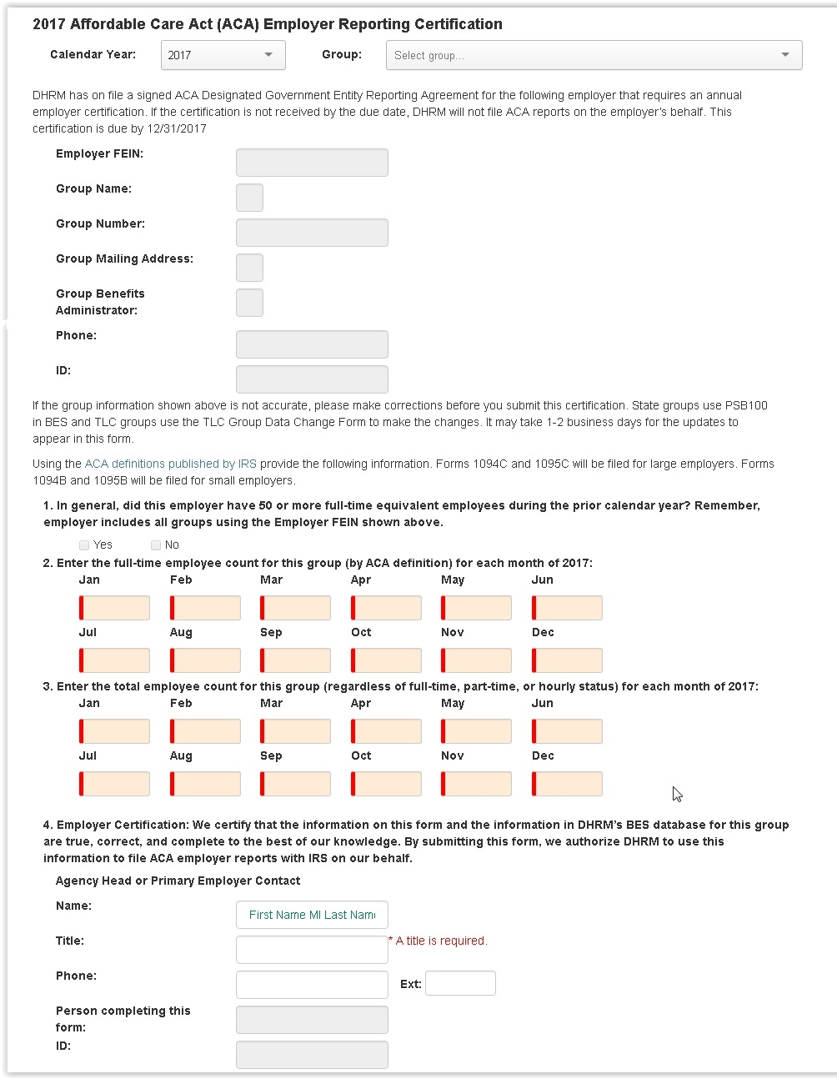

**Calendar Year:**

A user can select the year from a provided dropdown box. Selecting a non-active year will display a read-only view of any submitted data for that corresponding year. This option was preselected and not available to adjust for 2017 year.

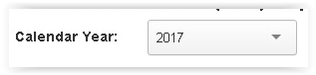

**Group:**

A user will be provided with their associated group(s) in the dropdown list. A user with only one group will have that group selected and the dropdown will not be shown.

An Admin user will have a dropdown list of any and all groups stored in the FEIN table.

**Pre-Filled Information:**

Upon selection of a group the following information is pre-filled with data retrieved from BES.

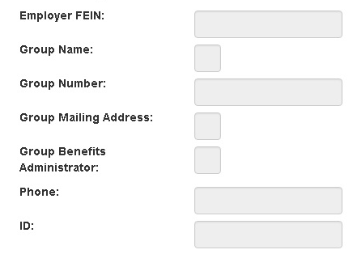

**Submit/Resubmit:**

Once completed a user can Submit the information.

Upon successful submission of the data there is an acknowledgement link at the bottom of the form stating the data has been received by DHRM.

The link can be used to view or print a local copy of the submitted ACA Certification.

Once submitted a RESUBMIT control is available for any future adjustments or corrections if the settings for that year are active.